**QUERY WRITING:**

1. **Single-Row function:**

**Ques:** Display the customer name, phone and address who are order the cup ice-cream

**Ans:** select c_name, c_phone, c_add

from customer

where i_name='Cup ice cream'

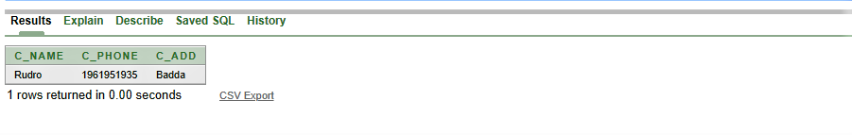

1. **Group function:**

**Ques:** Display the average amount of bill by customer number

**Ans:** select avg(amount)

from bill

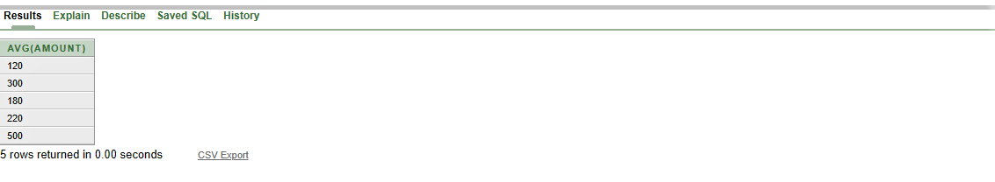 group by c_id

1. **Group function:**

**Ques:** Display the Sum of the salary of waiter as Total_salary by their name

**Ans:** select sum(salary) as total_salary

from waiter

group by w_name

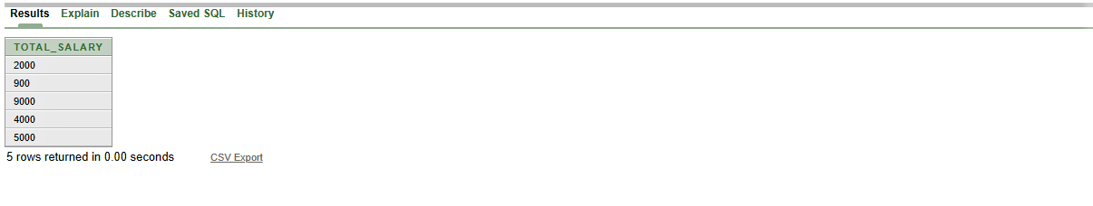

1. **Subquery:**

**Ques:** Display the manager name and manager number for all manager whose waiter number is 301

**Ans:** select m_name, m_id

from manager

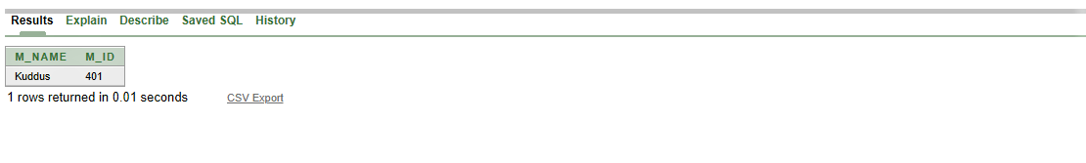 where w_id= (select w_id from waiter where w_id=301)

1. **Subquery:**

**Ques:** Display the owner number and phone number for all owners whose shop number is 704

**Ans:** select o_id, o_phone

from owner_shop

where s_id= (select s_id from shop where s_id=704)

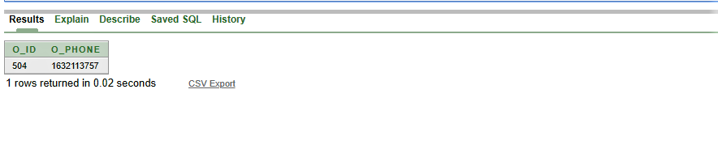

1. **Subquery:**

**Ques:** Display the customer number, name, phone and address for all customers who are order the Blue moon ice-cream

**Ans:** select c_id,c_name, c_add, c_phone

from customer

where i_name= (select i_name from ice_cream where i_name='Blue Moon ice cream')

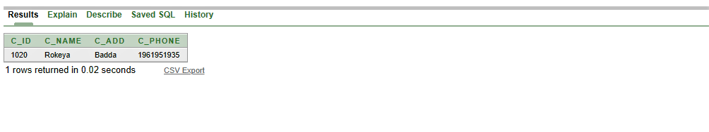

1. **Joining:**

**Ques:** Display the chef name, chef number, chef address and ice cream name for each chef

**Ans:** select c.ch_id, ch_name, address, I_name

from chef c, ice_cream i

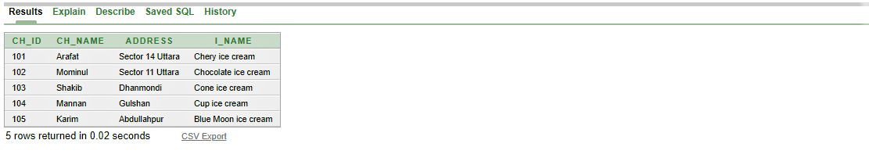 where c.ch_id= i.ch_id

1. **Joining:**

**Ques:** Display the customer name, customer number, address with ice cream name and their price for each ice cream

**Ans:** select c_id, c_name, c_add, c.I_name, i_price

from customer c, ice_cream i

where c.i_name= i.i_name

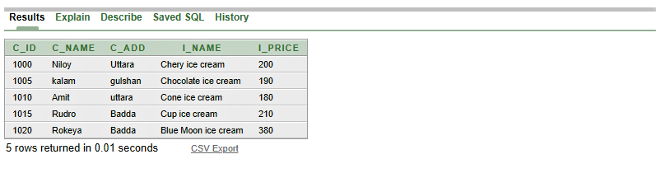

1. **Joining**

**Ques:** Display waiter name, salary and owner number for those waiter who earn more than 2000

**Ans:** select w.w_name, w.salary, w.o_id

from waiter_owner w, owner o

where w.o_id= o.o_id and w.salary>2000

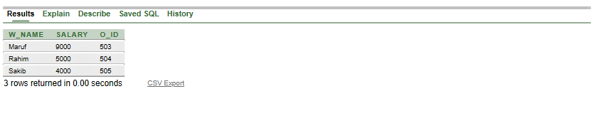

1. **View**

**Ques:** Create a view to see specific column customer name, customer number and their address

**Ans:** create or replace view C1

as

select c_name,c_id,c_add

from customer

